**Assignment 1**

Szabados Dávid

Used dataset:

<https://relational.fit.cvut.cz/dataset/CS>

This dataset is an artificial data from a Czech bank with 8 tables.

Tables documentation:

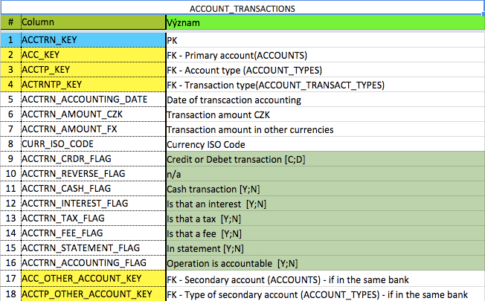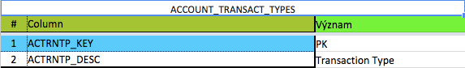

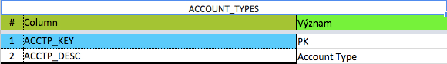

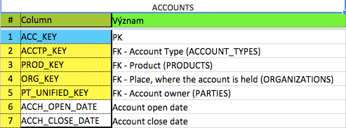

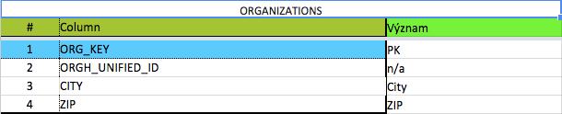

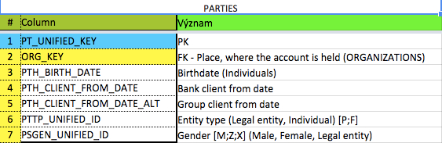

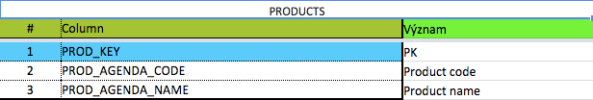

Questions:

Select cash transactions

Select closed accounts

Select accounts with gender as legal entity (X)

Procedures:

Return transactions with value minimum the amount that was given (in CZK)